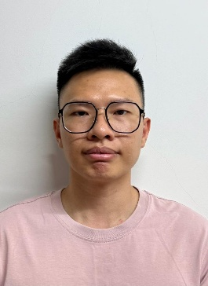
YAP FOOK HIN
Contact Information
Date of Birth : 19 May 1994
Phone: 016-317 8912
Email: Fookhinyap1994@gmail.com
Career Objective
Seeking a position Sales Executive where I can leverage 11 years of hands-on experience in
fiber laser cutting machines, strong demo capability, and in-depth knowledge of Raycus and IPG laser sources to provide professional solutions and support sales growth.

Professional Experience
Senior Laser Cutting Machine Technician / Application Specialist
Golden Laser (M) Sdn Bhd | 2014 – Present
- Provide professional on-site machine demonstrations, including setup, application testing, and technical explanations for fiber laser cutting machines.
- Conduct machine demonstrations and deliver clear presentations on machine specifications and laser source performance to customers.
- Specialize in fiber laser systems, with strong expertise in Raycus laser sources and solid working knowledge of IPG laser technology.
- Recommend appropriate laser parameters, diagnose and troubleshoot cutting issues, and deliver effective solutions to customer requirements.
- Support pre-sales technical consultations by proposing suitable technical solutions and application recommendations.
- Lead and manage a technical team, providing professional guidance and technical support to advise customers and resolve application challenges.

Core Skills
Fiber Laser Cutting Machine Application, Technical Sales Support, Machine Demo Setup &
Application Testing, Customer Consultation, Laser Parameter Optimization, Raycus Fiber Laser (Expert), IPG Fiber Laser, Industrial Machinery Knowledge, After-Sales Technical Support

Language
Chinese – Native | English – Intermediate | Bahasa Malaysia – Intermediate | Cantonese- Intermediate

