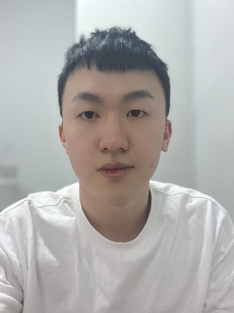 |  | NAME:  RICKY KANG JIN YUAN  Birthday:  20/07/200  Entertainment KTV Bar Operations Director
Profile  I am currently seeking a better work environment and development opportunities. I possess strong learning and adaptability skills, enabling me to quickly adapt to new roles and continuously improve myself. I am responsible and dedicated to my work, excel in communication and teamwork, and have five years of social experience, allowing me to collaborate effectively with diverse individuals. I am hardworking, resilient under pressure, and hope to secure a job opportunity that allows me to showcase my abilities and fosters long-term career growth.  Contact  PHONE:  +8562096569371  EMAIL:  xiaoyuan16889@gmail.com  LANGUAGES：  Chinese, English, Malay, some Thai  NATIONALITY：  MALAYSIA |  | EDUCATION  High school graduation  WORK EXPERIENCE  - 2019-2020: Food and beverage services  - 2021-2022: Bar Waiter/Waitress KTV Team Leader  - 2023-2023: Deputy Supervisor and Supervisor of Bar and KTV  - 2023-2025: Director of Bar and KTV  SKILLS  Experienced in entertainment industry management, with expertise in team coordination and resource integration. Skilled at optimizing operational processes and improving work efficiency. Possesses excellent communication and problem-solving abilities, capable of maintaining high performance in fast-paced environments. Dedicated to achieving organizational goals and driving continuous improvement.

